**MongoDB Assignment 1**

**Insert Document**

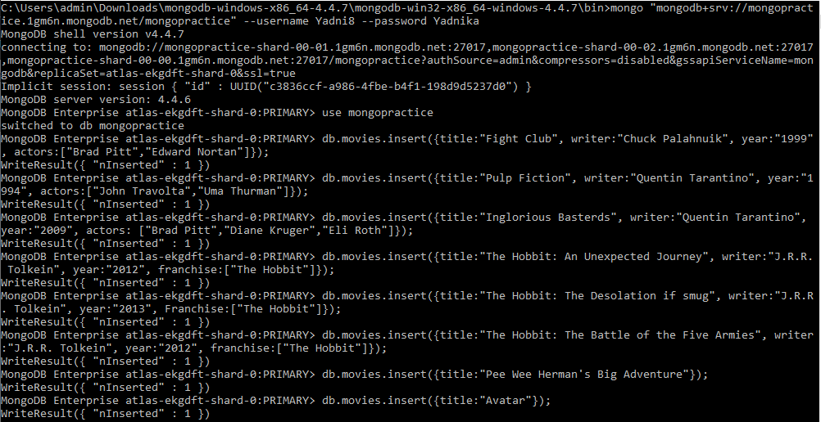

**Query/Find Document**

1.

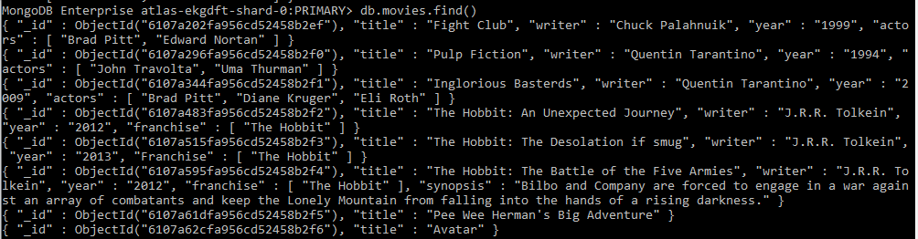

2.



3.



4.

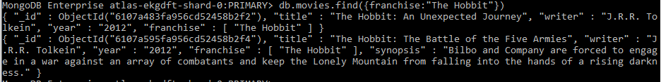

5.



6.

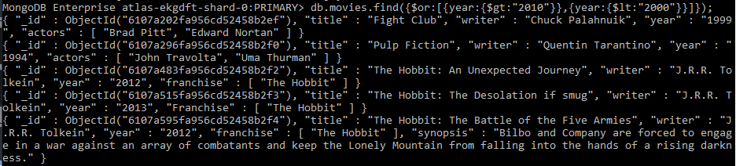

**Update Document**

1.

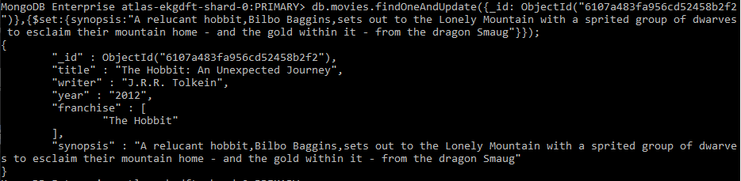

2.

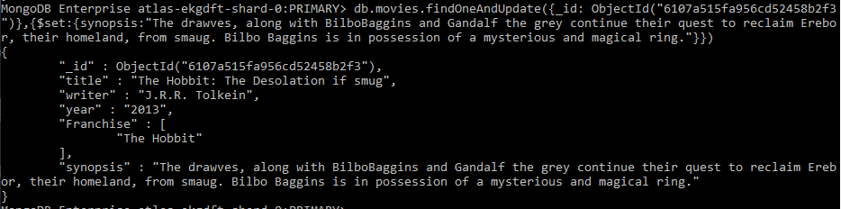

3.

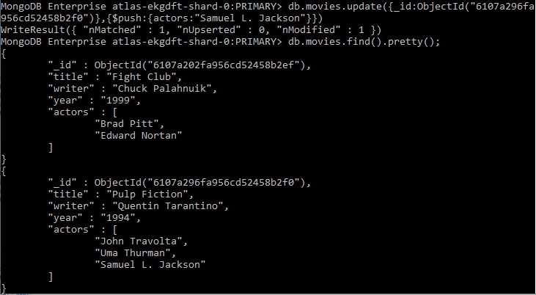

**Text Search**

1.

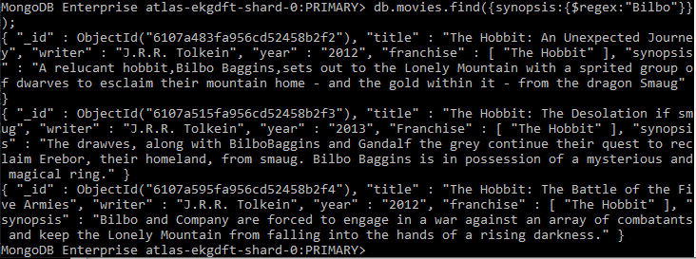

2.

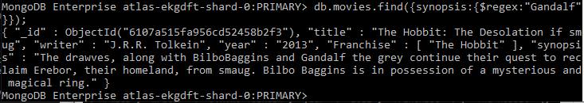

3.

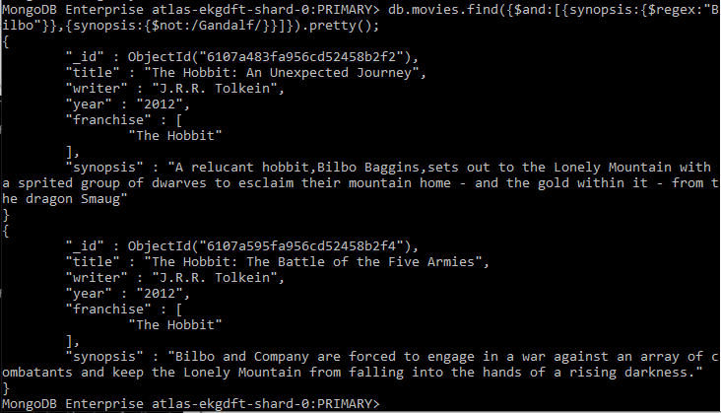

4.

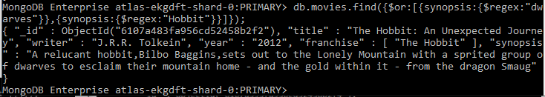

5.

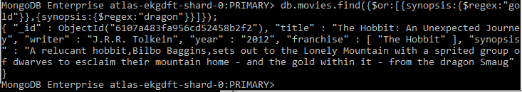

**Delete Documents**

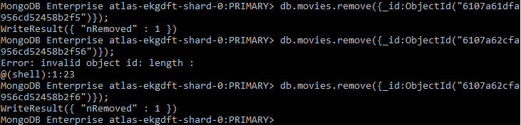

**Relationship**

**Insert Users Collection**

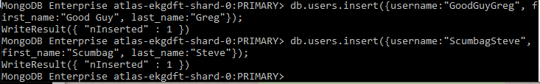

**Insert Posts Collection**

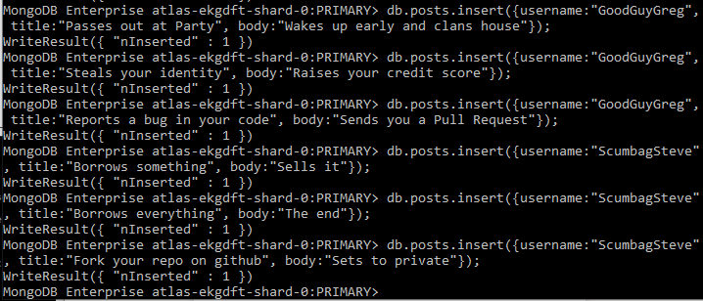

**Insert Comments Collection**

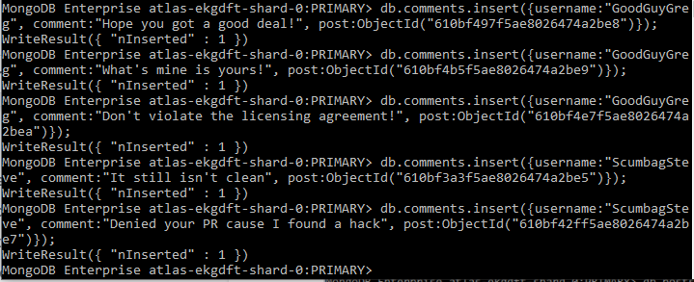

**Querying Related Collection**

**1.**

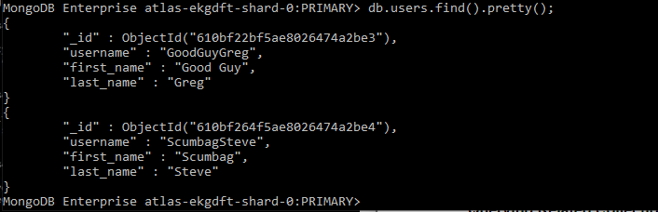

**2.**

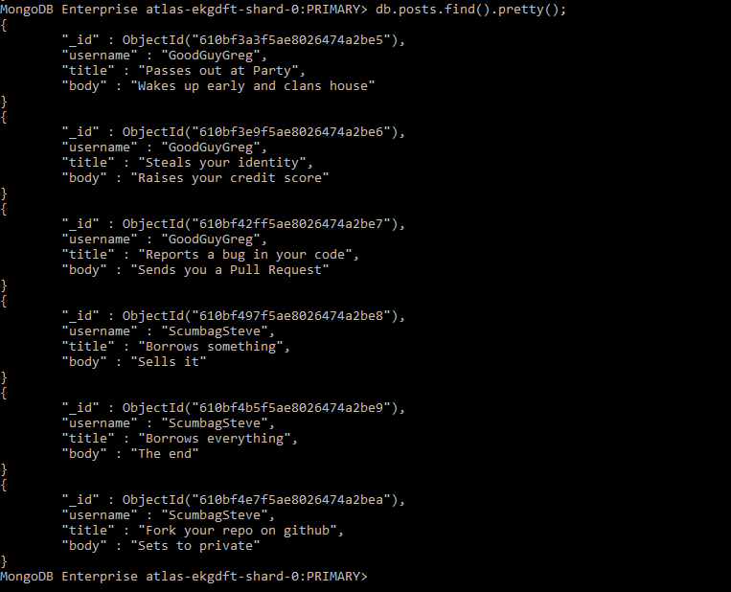

**3.**

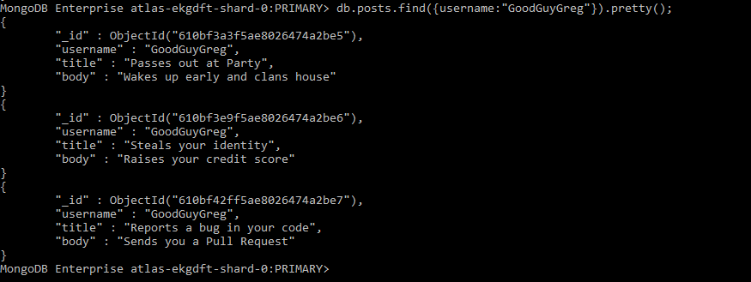

**4.**

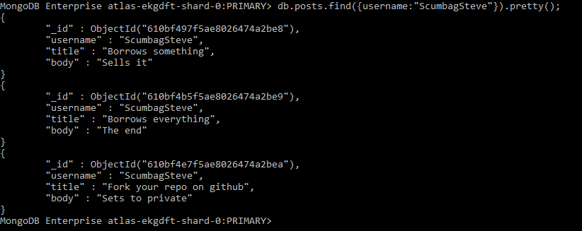

**5.**

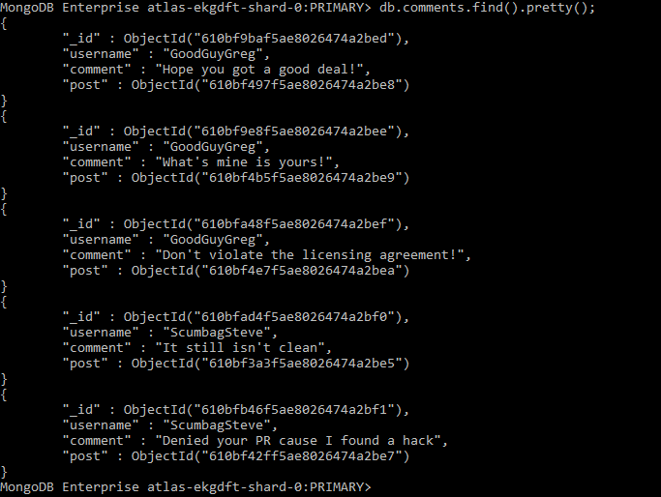

**6.**

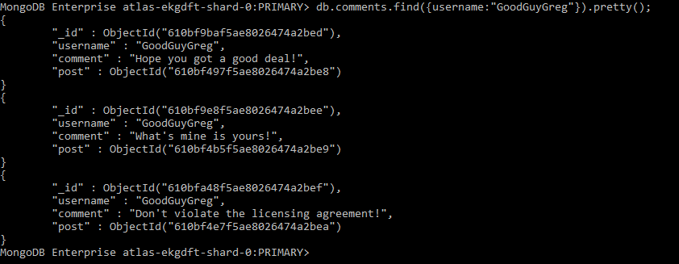

**7.**

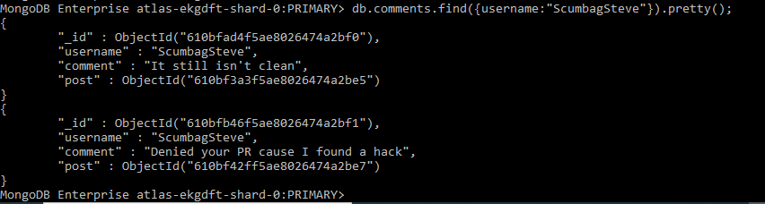

**8.**

